**Question 1**

(This question demonstrates where the “prisoner’s dilemma” got its name!)

Suppose there are two burglars, Bill and Bob, who are captured by the police leaving a house carrying stolen possessions. The police can prove that the two are guilty of trespassing but do not have enough evidence to convict them of burglary unless someone confesses. The police separate Bill and Bob and promise each one that if he testifies that the other committed the crime of burglary, they will drop the charge of trespassing.

Suppose that the penalty for trespassing is 1 year in jail, and the penalty for burglary is 4 years in jail. (Note that if one testifies and the other does not, the second will be convicted of both trespassing and burglary.)

A. Draw a table showing the strategies and payoffs for both burglars.

B. What is the Nash equilibrium of this game? Explain how you found it.

**Answer:** Bill

Testify Don’t testify

|  |  |
| --- | --- |
| 4,4 | 0,5 |
| 5,0 | 1,1 |

Testify

Bob

Don’t testify

B.For Bill, if Bob testifies, the better choice for him is to testify, if Bob doesn’t testify, the better choice for him is to testify. Therefore, overall, the best choice for Bill is to testify.

For Bob, if Bill testifies, the better choice for him is to testify, if Bill doesn’t testify, the better choice for him is to testify. Therefore, overall, the best choice for Bob is to testify.

The Nash equilibrium is for both to testify. This is because testifying is a dominant strategy for both Bill and Bob. For example, if Bob testifies, Bill is better off testifying and getting 4 years of jail instead of 5 years. If Bob does not testify, Bill is still better off testifying and getting 0 instead of 1 year of jail. The same logic applies to Bob’s decision.

**Question 2**

Hattie and Mattie are the first two residents of Frankland Island to own cars. Before them, everyone else walked. One day, they meet, heading in opposite directions on the same road. The following table summarizes their choices and outcomes.

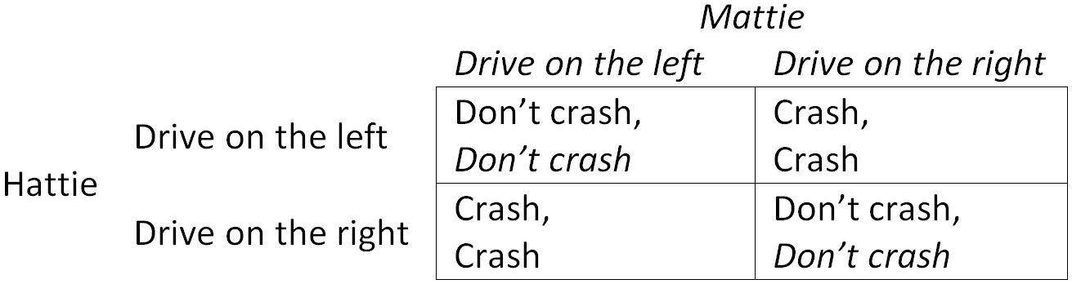

How many Nash equilibria can you find? If more than one, which one do you think is the most likely outcome?

**Answer:**

For Hattie, if Mattie drives on the left, the better choice for him is to drive on the left, if Mattie drives on the right, the better choice for him is to drive on the right.

For Mattie, if Hattie drives on the left, the better choice for him is to drive on the left, if Hattie drives on the right, the better choice for him is to drive on the right.

This is an example of coordination game. There are two Nash equilibria, one in which both drive on the left and one in which both drive on the right. There is no way to know which will actually occur. In fact, while in most countries, cars are driven on the right, in many countries, such as Australia, cars are driven on the left. What is important is that everyone follows the same rule, not what the rule is.

(Note: There is also a third, “mixed strategy”, equilibrium in which each driver chooses which way to drive randomly and goes each way 50% of the time. Of course, this equilibrium is very unlikely to occur in real life because it will result in crashes 50% of the time, so both would have a great incentive to find a way to communicate (or make a rule) to push them toward one “pure strategy”equilibrium or another.)

**Question 3**

Suppose that there are two petrol stations in a suburb, Frank’s Fuel and Pete’s Petrol. Suppose that both purchase petrol on the wholesale market for $1/litre and have no other costs. The demand schedule for petrol is

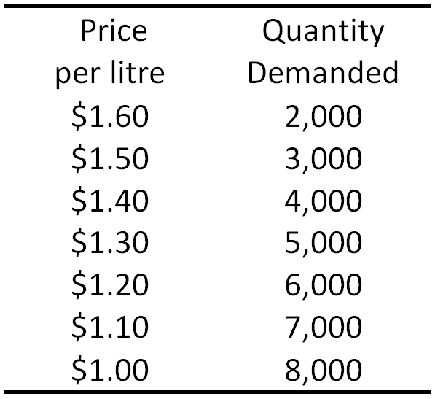

A. If Frank’s and Pete’s work together to maximize total profits and split them evenly, what price will they charge? How much profit will each make?

B. Now, suppose that Frank’s decides to cut its price by $0.10. How much profit will each make? What if Pete’s also cuts its price at the same time?

C. Draw a table showing how the profits of each petrol station depend on its own price and the price of the other one. (You can restrict your answer to the two prices you have already considered.)

D. Based on this, which price is likely to be charged by the petrol stations?

**Answer:**

A.

|  |  |  |  |
| --- | --- | --- | --- |
| Price per litre | Quantity Demanded | Total Revenue | Marginal Revenue |
| $1.60 | 2000 | $3200 | --- |
| $1.50 | 3000 | $4500 | $1.30 |
| $1.40 | 4000 | $5600 | $1.10 |
| $1.30 | 5000 | $6500 | $0.90 |
| $1.20 | 6000 | $7200 | $0.70 |
| $1.10 | 7000 | $7700 | $0.50 |
| $1.00 | 8000 | $8000 | $0.30 |

If they work together, Frank’s and Pete’s can act like a single monopolist. Therefore, they will charge the price for which marginal revenue equals marginal cost.

According to the table, this occurs where P=$1.40. Total profit will be $5,600– 4,000x$1 = $1,600, so each station will earn $800.

B.If Frank’s cuts its price, but Pete’s does not, Frank’s will capture the entire market. Therefore, Frank’s will earn a profit of $6,500–5,000x$1 = $1,500, and Pete’s will earn $0. If both cut their price, they will each earn $750.

C. Pete’s

Cut the price Don’t cut the price

|  |  |
| --- | --- |
| $750,$750 | $1500,$0 |
| $0,$1500 | $800,$800 |

Cut the price

Frank’s

Don’t cut the price

D.This is an example of a “prisoner’s dilemma” game. Both players have a dominant strategy, which is to cut their price. As a result, the Nash equilibrium is for both to charge $1.30 and earn $750 in profit.

**Question 4**

Vance Harmstrong and Umberto Dumbledore are cyclists who will compete in a race for a prize of $1,000,000. They are evenly matched and will tie under normal circumstances. However, each can cheat by taking a drug that will make them faster but damage their long-term health. Suppose that each values being healthy at $400,000 and that they will split the prize if they tie.

A. Draw a table showing the strategies and payoffs for both cyclists.

B. Find the Nash equilibrium for their game.

C. Suppose instead that Umberto values being healthy at $600,000. How will the equilibrium change? In addition, suppose that Umberto can earn $100,000 as a sales representative if he does not spend his time training for the race. Will he choose to enter the race?

D. In the original case, suppose that race sponsors can spend $200,000 (which they will take out of the prize money) to drug test both cyclists, and they decide that if the winner cheats, no one will win the prize money. How will this affect the payoffs of the cyclists in a Nash equilibrium.

**Answer:**

A. Umberto

Cheat Don’t cheat

|  |  |
| --- | --- |
| $1,$1 | $6,$0 |
| $0,$6 | $5,$5 |

Cheat

Vance

Don’t cheat

B.As in a standard prisoner’s dilemma game, Vance and Umberto each have a dominant strategy, which is to cheat. Thus, (Cheat, Cheat) is the Nash equilibrium.

(Economists call this type of game, which is a special case of a prisoner’s dilemma, an “arms race” because it resembles the case of two countries using their resources to build weapons in a race to have the strongest military, only to be left poorer and equally powerful to one another.)

C. Umberto

Cheat Don’t cheat

|  |  |
| --- | --- |
| $1,$-1 | $6,$0 |
| $0,$4 | $5,$5 |

Cheat

Vance

Don’t cheat

Vance still has a dominant strategy of Cheat, but now Umberto has a dominant strategy of Don’t Cheat, so the Nash equilibrium is (Cheat, Don’t Cheat), and Vance will always win the race.

Given that Umberto’s payoff will always be $0, since he will never cheat and never win, he would prefer to work as a sales representative and not enter the race.

(This is an example of what economists call “adverse selection”. In this case, only those who are most willing to cheat enter the race because everyone understands that those who are more willing to cheat will always win. Eventually, the race will consist only of cheaters. Other examples of markets with an adverse selection problem are used car markets and insurance markets. The latter is an important reason why it may make sense for the government to provide health care for everyone, because in a competitive market for health insurance, only the sick will want to purchase insurance!)

D. Umberto

Cheat Don’t cheat

|  |  |
| --- | --- |
| $-4,$-4 | $-4,$0 |
| $0,$-4 | $4,$4 |

Cheat

Vance

Don’t cheat

Now, both players have a dominant strategy of Don’t Cheat, so they will tie and split the $800,000 prize. Interestingly, even though every option is worse for both players than in the original case, the outcome is actually better!

**Question 5**

Suppose that there are two farmers, Earl and Pearl, who graze their milk cows on the common pasture of their village. Each farmer can purchase up to two cows, and the more cows that are on the pasture, the less grass there will be per cow, meaning each cow will produce less milk. Suppose that cows cost $500 each and milk sells for $2 per litre. The following table summarizes the production of each cow given the number in the pasture.

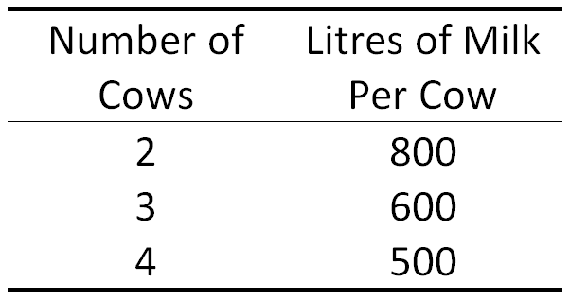

What is profit of each farmer in the Nash equilibrium? What would be the efficient number of cows?

**Answer:**

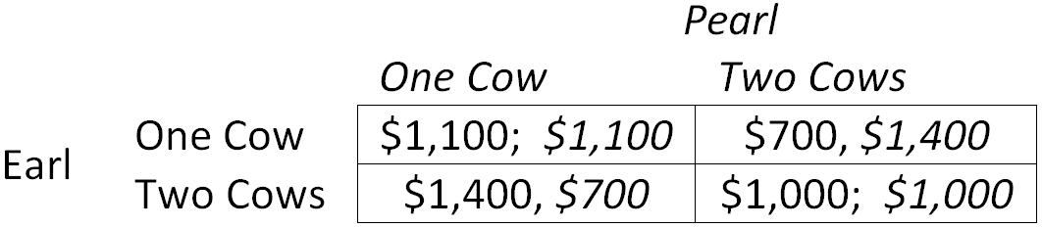

Two cows is a dominant strategy for both farmers, so each farmer will earn $1,000 in the Nash equilibrium. The efficient number of cows is 2 (total) because this is the number maximises the value of milk produced minus the cost of the cows.

(This is an example of what economists call the “tragedy of the commons”, which is when common resources, like the pasture in this case, are overused because individuals do not take into account that their use of the resource reduces its usefulness to others. In this case, each farmer did not take into account that adding an additional cow to the pasture reduces the milk produced by other farmers’ cows. This is a common problem with open-access resources, for example, overfishing in unregulated fisheries and hunting of endangered species.)

**Question 6**

Two students, April and May, have been given the choice to work on a difficult assignment together or a simple one separately. The difficult assignment is worth 100 marks for each student, and each simple assignment is worth 70 marks. Each student will get a perfect mark (70) on the simple assignment if she works on that one. If both work on the difficult assignment, they will get a perfect mark (100), but if only one works on it, she will get a 0 because it will be incomplete.

Unfortunately, the students cannot communicate until the moment before they hand in their assignments. So, their payoffs are summarized by the following table

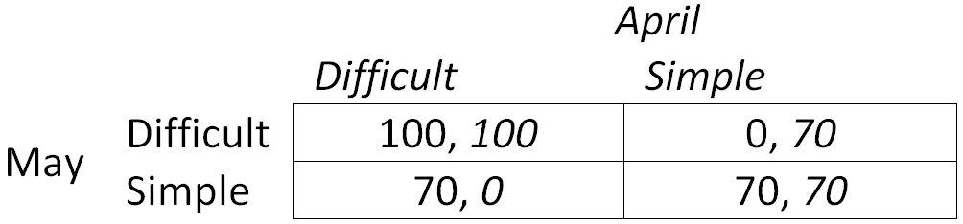

Find the Nash equilibria. Which one do you think is the most likely outcome?

**Answer:**

This is another example of coordination game. (Difficult, Difficult) and (Simple, Simple) are both Nash equilibria. As with the Stadium/Theatre example in Chapter 8.4, one of the equilibria is more desirable, so we may think that (Difficult, Difficult) is more likely to be chosen. However, in this case, there is a reason to think (Simple, Simple) might also be likely. For both students, Simple is a safer choice. They will get 70 marks no matter what the other does. On the other hand, if May chooses Difficult, then she will either get 100 or 0, depending on what April does. So, if April and May are “risk averse”, they may both choose Simple, even though they would both be better off if both chose Difficult.

(This is an example of a special case of a coordination game known as a “stag hunt”. The name goes back to a story told by French philosopher Jean-Jacques Rousseau in Discourse on Inequality (1754). It is an example of a case in which cooperation is best for everyone, but it is risky because success depends on others cooperating as well. So, achieving the best outcome can be helped by trust and a sense of community, things you may not expect to hear economists talk about!)